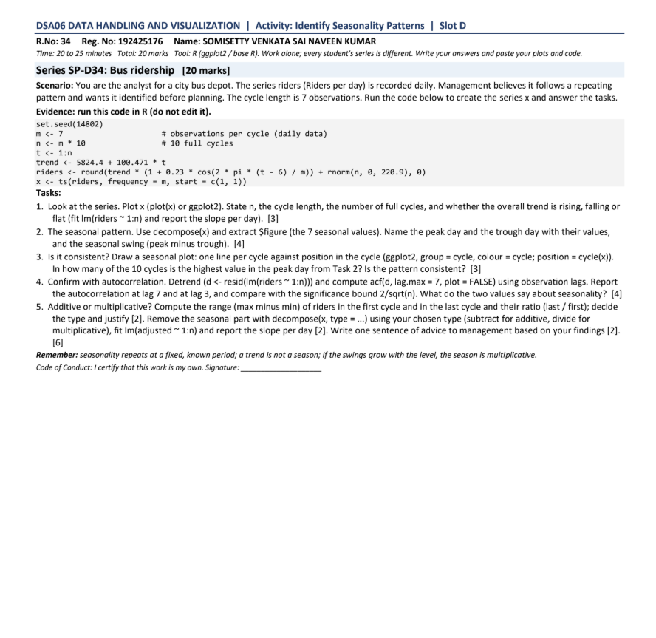

Series SP-D34: Bus Ridership [20 marks]

R Code (Evidence)
set.seed(14802)
m <- 7 # observations per cycle (daily data)
n <- m * 10 # 10 full cycles
t <- 1:n
trend <- 5824.4 + 100.471 * t
riders <- round(trend * (1 + 0.23 * cos(2 * pi * (t - 6) / m)) + rnorm(n, 0, 220.9), 0)
x <- ts(riders, frequency = m, start = c(1, 1))

Task 1. The series and trend [3]

R Code
plot(x) # or ggplot2
length(x); frequency(x); length(x) / frequency(x)
fit <- lm(riders ~ 1:n)
coef(fit)
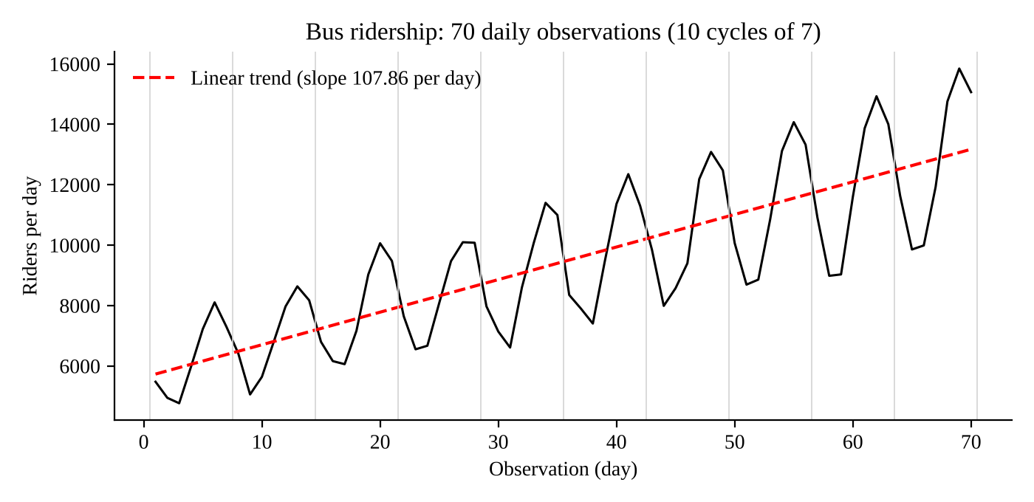
Figure 1. Daily riders with the fitted linear trend (grey lines mark cycle boundaries)
The series has n = 70 observations, the cycle length is 7 observations (daily data) and there are 70 / 7 = 10 full cycles. The overall trend is rising: the fitted line riders = 5,624.8 + 107.86 x (day) has a slope of +107.86 riders per day, so ridership grows by about 108 riders every day (about 755 per week).

Task 2. The seasonal pattern [4]

R Code
dec <- decompose(x)
round(dec$figure, 2)
which.max(dec$figure); max(dec$figure)
which.min(dec$figure); min(dec$figure)
max(dec$figure) - min(dec$figure)
Position in cycle | Seasonal value (riders)
1 | -565.94
2 | -1,943.97
3 (trough) | -2,010.17
4 | -443.79
5 | 1,316.91
6 (peak) | 2,176.49
7 | 1,470.46

The peak day is day 6 of the cycle, with a seasonal value of +2,176.49 riders above the trend. The trough day is day 3, with a seasonal value of -2,010.17 riders below the trend. The seasonal swing (peak minus trough) is 2,176.49 - (-2,010.17) = 4,186.66 riders. The seven values sum to zero, as an additive decomposition requires.

Task 3. Is it consistent? [3]

R Code
df <- data.frame(riders = as.numeric(x),
cycle = factor(floor((t - 1) / m) + 1),
pos = as.numeric(cycle(x)))
ggplot(df, aes(pos, riders, group = cycle, colour = cycle)) +
geom_line() + geom_point() + scale_x_continuous(breaks = 1:7) +
labs(x = "Position in cycle", y = "Riders per day") + theme_minimal()

peak_pos <- tapply(df$riders, df$cycle, which.max)
peak_pos
sum(peak_pos == which.max(dec$figure))
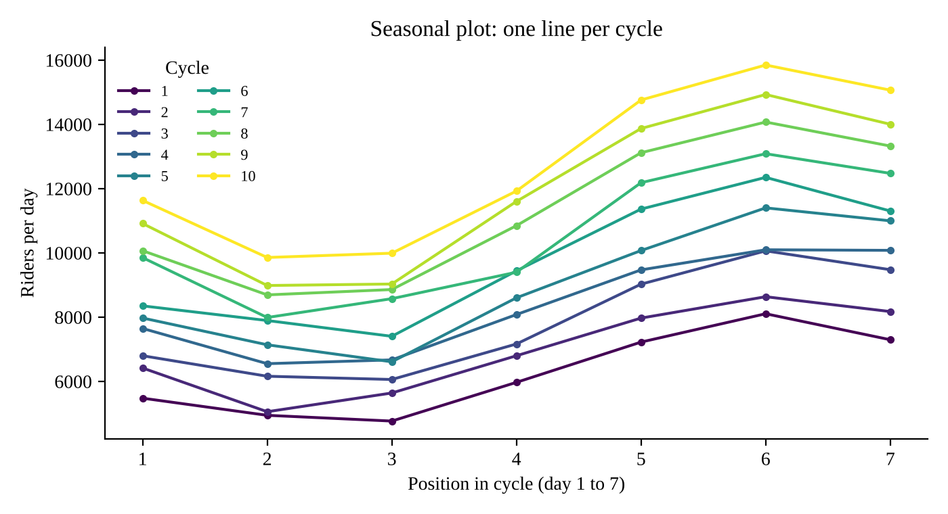
Figure 2. Seasonal plot with one line per cycle
The highest value of every one of the 10 cycles falls on day 6, which is the peak day found in Task 2, so the count is 10 out of 10. The pattern is therefore consistent: the ten lines in Figure 2 have the same shape (low at days 2 and 3, rising to a high at day 6, then easing at day 7) and are simply stacked higher in each later cycle because of the upward trend.

Task 4. Confirm with autocorrelation [4]

R Code
d <- resid(lm(riders ~ 1:n))
a <- acf(d, lag.max = 7, plot = FALSE)
round(a$acf[2:8], 3) # lags 1 to 7
2 / sqrt(n) # significance bound
Quantity | Value
Autocorrelation at lag 7 | 0.869
Autocorrelation at lag 3 | -0.833
Significance bound 2 / sqrt(70) | +/- 0.239

The autocorrelation at lag 7 is r = 0.869 and at lag 3 it is r = -0.833, and the bound is 2 / sqrt(70) = 0.239. Both values lie far outside the bound, so both are statistically significant. Lag 7 is strongly positive: a day resembles the same day one cycle (7 observations) earlier, which is the signature of seasonality with a fixed period of 7. Lag 3 is strongly negative because three days apart is roughly half a cycle, so a peak day is compared with a trough day. Together the large positive value at the full period and the large negative value at about half a period confirm a genuine repeating pattern of length 7.

Task 5. Additive or multiplicative? [6]

R Code
first <- x[1:7]; last <- x[64:70]
r1 <- max(first) - min(first)
r10 <- max(last) - min(last)
r1; r10; r10 / r1

dm <- decompose(x, type = "multiplicative")
adjusted <- x / dm$seasonal
coef(lm(adjusted ~ 1:n))
Quantity | Value
Range of the first cycle (max - min) | 8,107 - 4,767 = 3,340
Range of the last cycle (max - min) | 15,848 - 9,858 = 5,990
Ratio (last / first) | 1.79
Slope of the adjusted series | 101.38 riders per day

Type and justification. The season is multiplicative. The swing between the best and worst day grows with the level of the series: the range rises from 3,340 in the first cycle to 5,990 in the last (a ratio of 1.79), while the average level roughly doubles (from about 6,256 to 12,726 riders per day, a ratio of 2.03). In an additive season the range would stay roughly constant, but here it scales with the level, which matches the data being generated as trend x (1 + seasonal effect).
Adjusted series. After removing the seasonal part with decompose(x, type = "multiplicative") and dividing (adjusted = x / seasonal), the fitted line has a slope of 101.38 riders per day. This is the trend growth with the weekly pattern removed and it is close to the slope of 107.86 from Task 1.
Advice to management. Plan capacity as a percentage of the trend rather than a fixed number of extra riders: day 6 runs about 23% above the trend and days 2 and 3 about 20% below it, with the trend itself growing by about 101 riders per day, so schedule the largest fleet on day 6 and the smallest on days 2 and 3 and increase all of them as the trend rises.
Remember: seasonality repeats at a fixed, known period (7 here); a trend is not a season; and because the swings grow with the level, the season is multiplicative.

